CADENCE Module Reuse for QN9020

This document describes how to use the module reuse function of Cadence for QN9020 designing in different application.

In the following, there is an example to explain how to use this function.

1. Download the qn9020_module_reuse.rar file offered by NXP Corporation and extract it into computer’s location of your choosing. E.g. D:\quintic

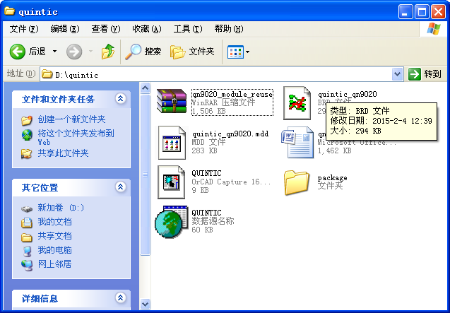

1. Create schematic with Orcad Capture tool

File-New-Project

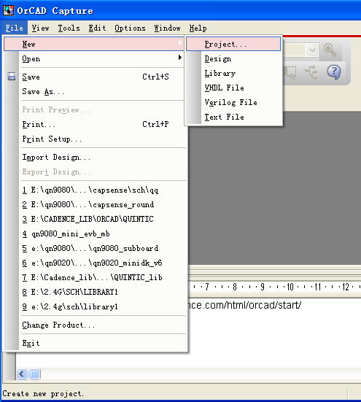

Named project and select location, then press OK

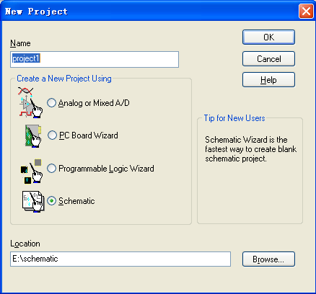

In this screen, press short Key “P” to add the Qn9020 part

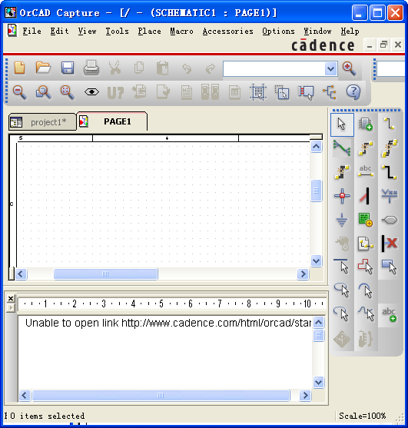

The default library has not contain the QN9020 part, So we need to add the QUINTIC library which contains QN9020 part

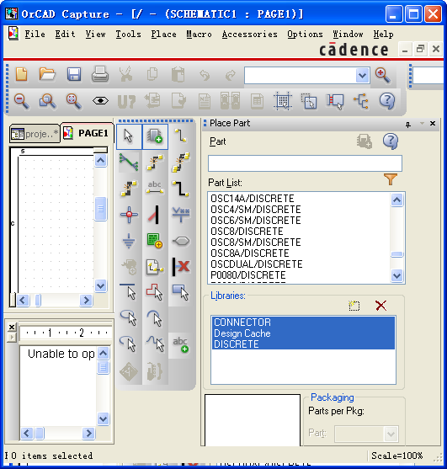

Then the QN9020 part will be appeared in the following screen

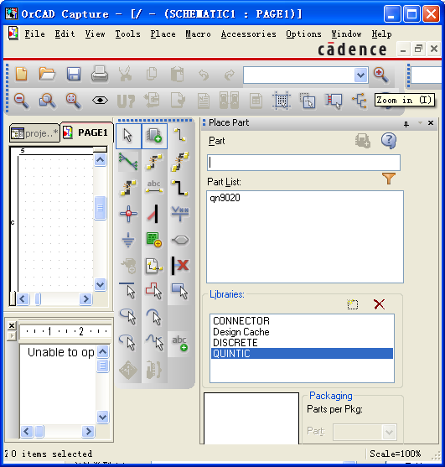

Press short key “Alt+A” to open browse file and select the “QUINTIC.olb”

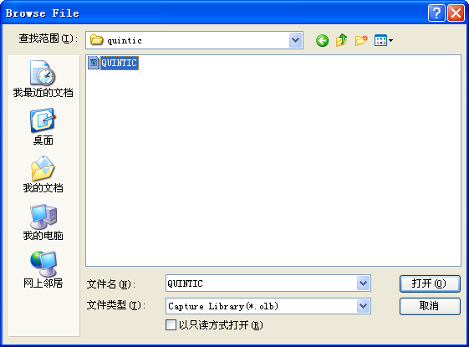

Place QN9020 part on the schematic design window

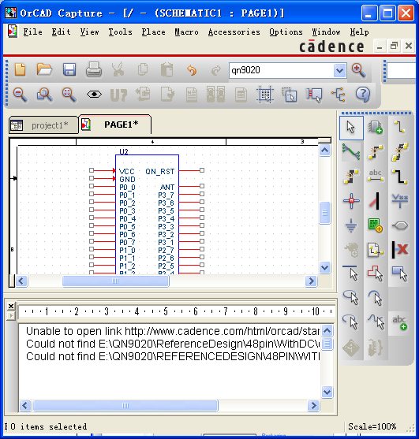

Double click the Qn9020 part

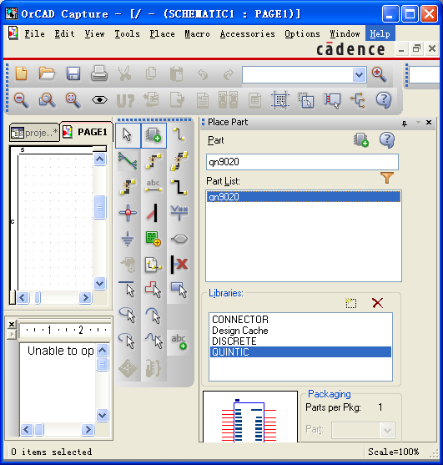

Modify the name U* to H1

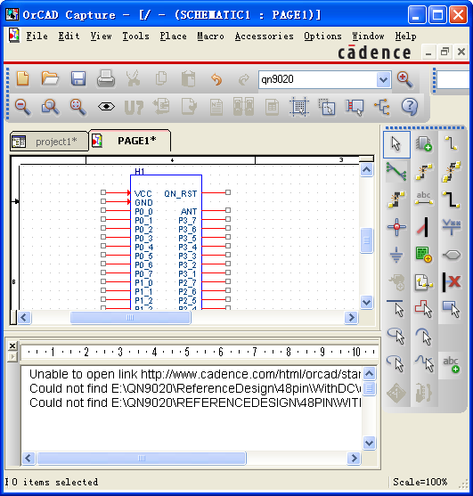

Double click the H1 and assign the implementation path to the above extracted choosing path

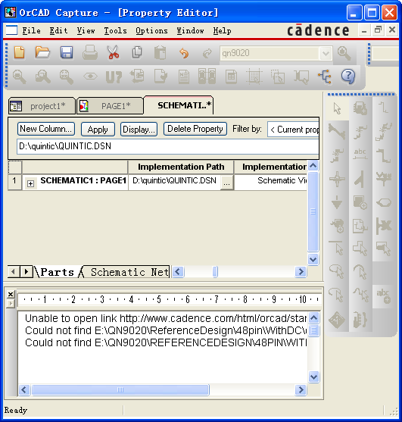

Following the above steps, the part QN9020 module is placed successfully, and you can add the other parts in this design

1. Create Netlist

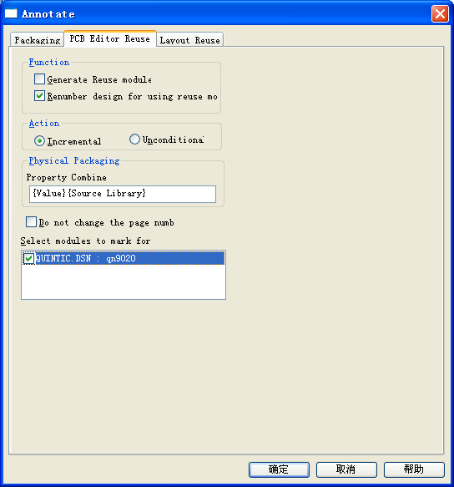

Tool-annotate

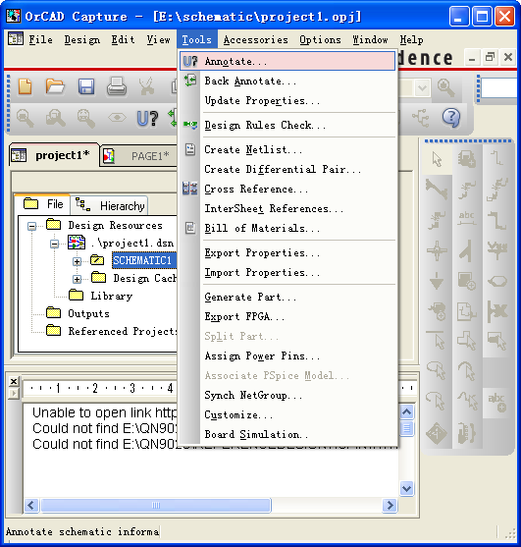

Tool-Create Netlist

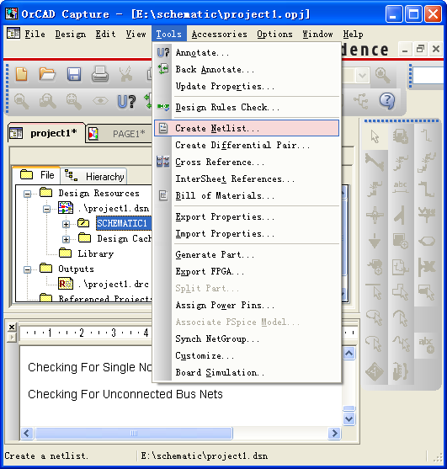

Tool-Design Rules Check

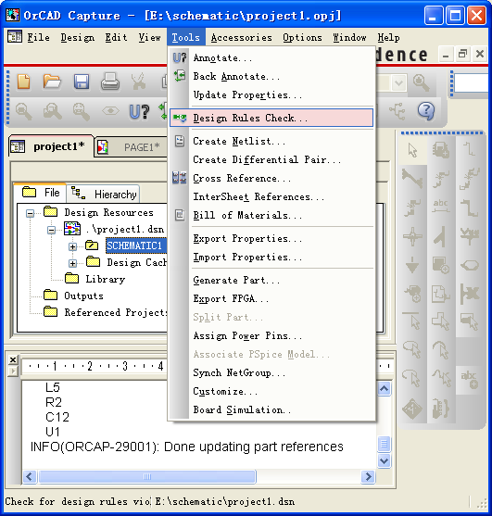

1. Module layout

File-New-board and change project directory path

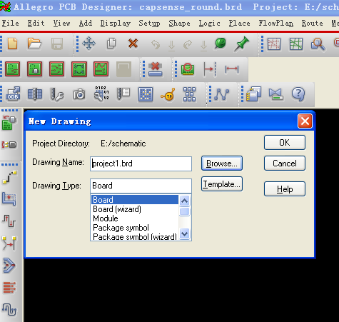

Setup-User Preferences

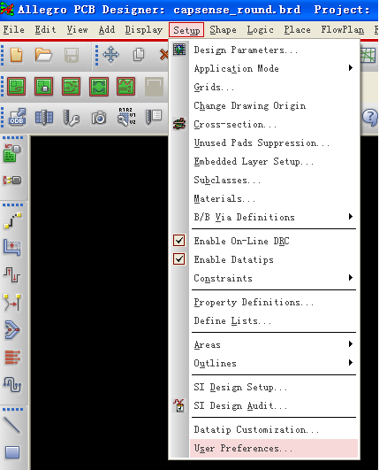

Select Paths-library-module path and add the QN9020 module library directory. e.g. D:\QUINTIC\

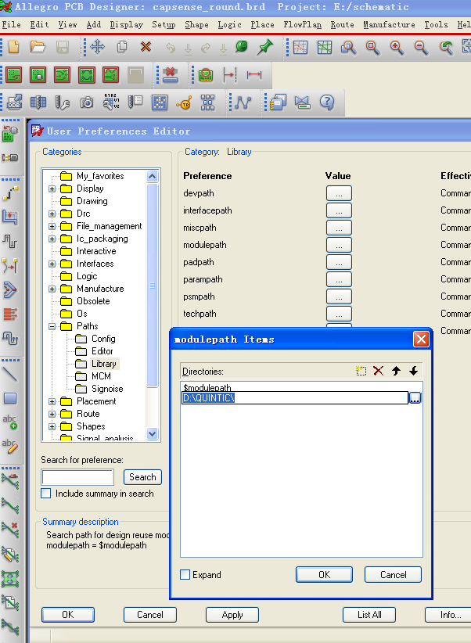

In same way, add the padpath and Psmpath directory.

e.g. D:\QUINTIC\package\

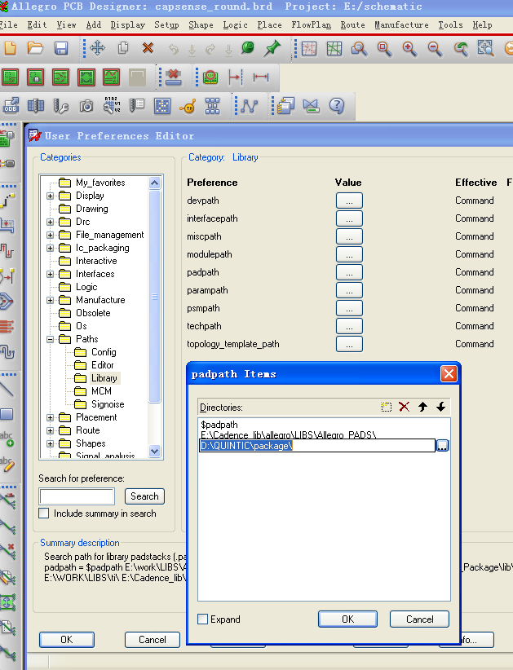

Press “off” marked with red circle to turn off all layer color

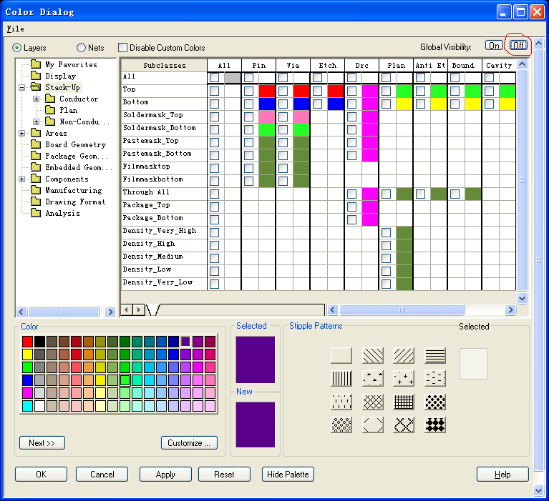

Display-Color/Visibility

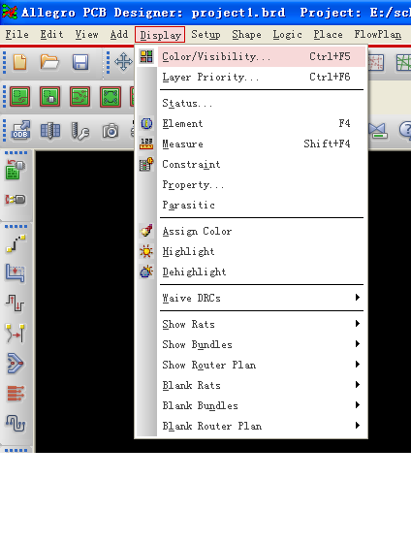

Select Board Geometry and assign color to outline

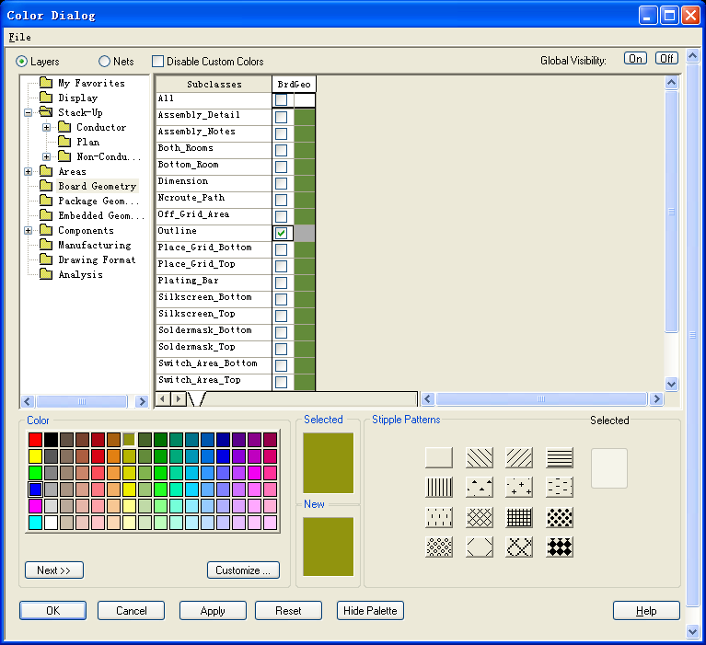

Select Stack-up and assign different color to TOP and Bottom layer

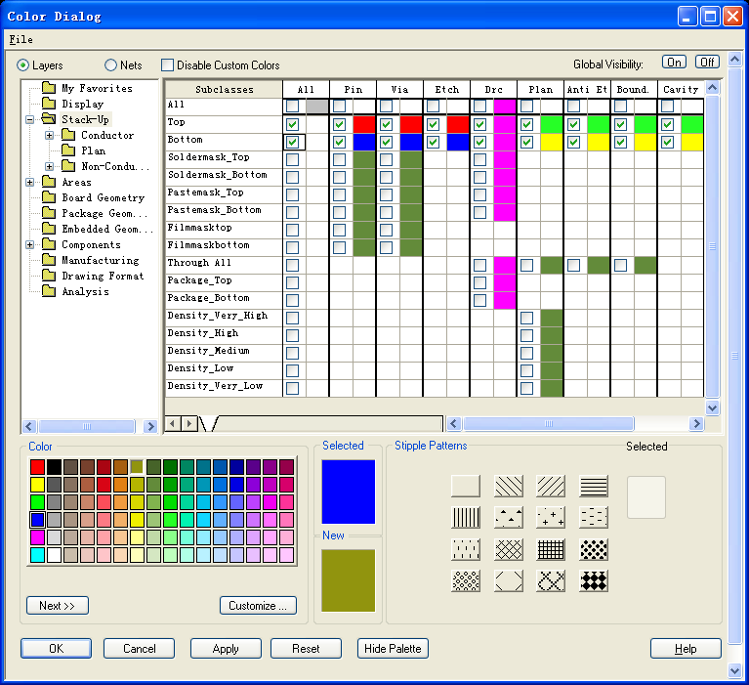

Select Components and assign color to

Silkcreen_top & bottom. Then Click OK

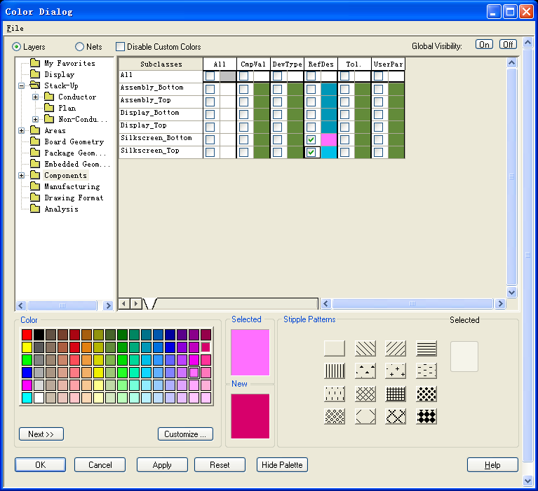

Select Package Geometry and assign color to Silkcreen_top & bottom

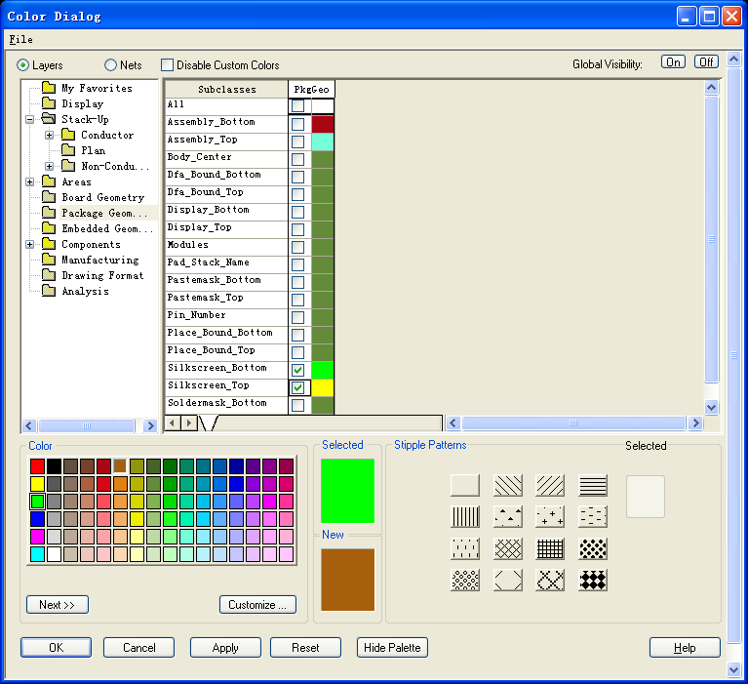

Select Design entry CIS, change the import directory and press “Import Cadence”

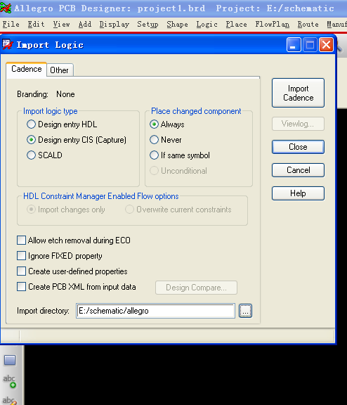

File-Import-Logic

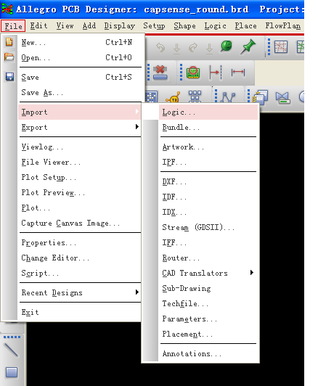

Place-Manually

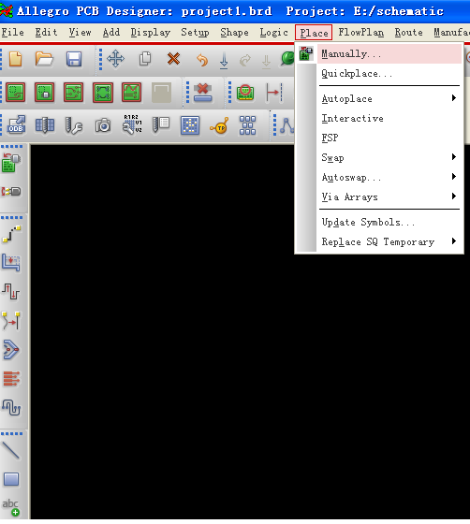

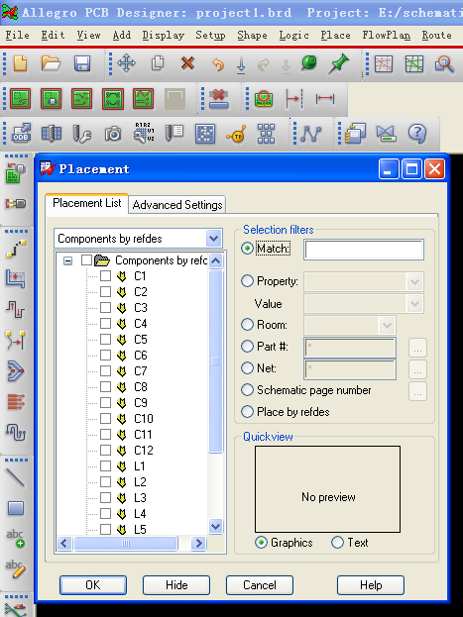

From the drop down menu to select module instances, the Qn9020 module will be in there

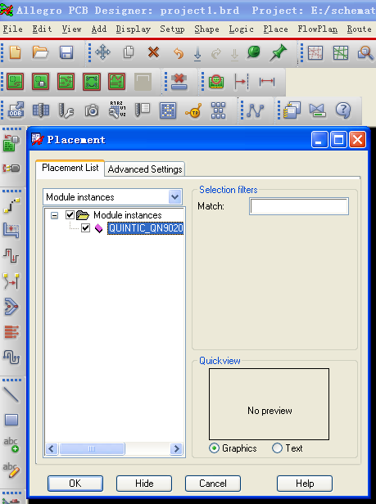

Select the Quitnic_QN9020 module and Place it on the edit window. Then click OK to close the placement window. The QN9020 module is successful to be reused.

